RAJALAKSHMI ENGINEERING COLLEGE
RAJALAKSHMI NAGAR, THANDALAM – 602 105



AD23B31 Image Processing and Computer Vision
Laboratory Record Note Book

Name : | ………………………………….
Year / Branch / Section : | ………………………………….
University Register No. : | ………………………………….
College Roll No. : | ………………………………….
Semester : | ………………………………….
Academic Year : | ………………………………….

DEPARTMENT OF COMPUTER SCIENCE AND ENGINEERING

AD23B31 Image Processing and Computer Vision

NAME
ROLL NO
YEAR
SEC


RAJALAKSHMI ENGINEERING COLLEGE
An Autonomous Institution

BONAFIDE CERTIFICATE

Name: ……………………………………………………………………………
Academic Year: …………… Semester: …………… Branch: ……………
Register No.

Certified that this is the bonafide record of work done by the above student in the…………………………………………………………………… Laboratory during the academic year 2025 – 2026.

Signature of Faculty in-charge

Submitted for the Practical Examination held on …………………

Internal Examiner External Examiner
INDEX

SlNO | Experiment | Date | GitHub
1 | Installation of Open CV & To perform the basic image handling processing operation on the image | 03/01/2026 | 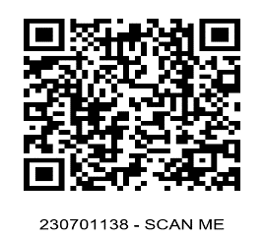
2 | Implement Edge Detection, Line Detection and Corner Detection | 10/01/2026
3 | Demonstrate Camera Calibration using python | 24/01/2026
4 | Implement Image Histogram and Histogram Equalization | 31/01/2026
5 | Develop a python program for Skin color Detection | 07/02/2026
6 | Create a python program for Warping and Estimation | 14/02/2026
7 | Develop a python program for Motion Tracking | 21/02/2026
8 | Design a program for Object Detection using YOLO | 07/03/2026
9 | Develop a python program for Stereo Vision and Depth Estimation | 14/03/2026
10 | Demonstrate Augmented reality using feature matching | 04/04/2026
11 | MiniProject - Face Mask Compliance Detection System | 11/04/2026, 18/04/2026, 25/04/2026, 02/05/2026

